China FRP Profile manufacturer,supplier ,factory,exporter in china

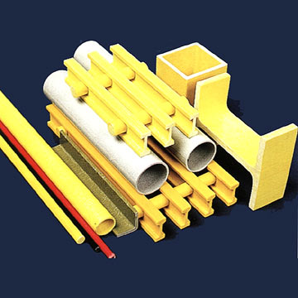
Product Name: FRP Profile
Place of Origin: China
Brand Name: Grand Fiberglass
Quality/Safety Certifications: ISO9001
FRP profile are produced from fiberglass roving with continual strand mat as reinforcement and unsaturated polyester resin as the matrix material. These products are widely used in handrails, supports, beams and other structural materials.

Contact Information :
Company Name: Grand Fiberglass Co., Ltd.
Contact Person: Richard Lu
Address: 513 Zhongxing Road, Ningbo, Zhejiang Province. China
Zip: 315040
Telephone: 0086-574-87808408,87802848
Fax: 0086-574-87803039
Website: http://www.fibreglassmesh.com/
Other Products : Fiberglass Mesh , Fire Blanket , fiberglass tissue , Fiberglass Tape , scrim tape , self adhesive fiberglass tape , drywall joint tape , fiberglass disc , Grinding Wheel , grinding disc , abrasive wheel , texturized fiberglass , fiberglass fabric, fiberglass cloth , fiberglass insect screen , insect screen ,mosquito net , FRP grating , FRP Profile ,FRP bathtub

