China Fiberglass Tape manufacturer,supplier ,factory,exporter in china

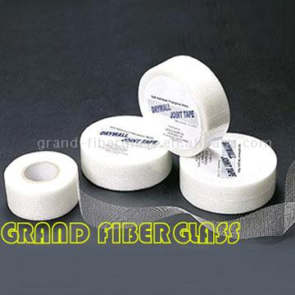
Product Name: Fiberglass Tape
Place of Origin: China
Brand Name: Grand Fiberglass
Quality/Safety Certifications: ISO9001
Fiberglass tape is woven from fiberglass bulk yarn, then coated with anti-alkaline resin and gum solution. It is then cut using a special machine.
This tape is very strong and self- adhesive, and used in various construction applications. These include reinforcing wall cracks, board cracks, plasterboard cracks and marble cement; in addition to repairing drywall joints.
Contact Information :
Company Name: Grand Fiberglass Co., Ltd.
Contact Person: Richard Lu
Address: 513 Zhongxing Road, Ningbo, Zhejiang Province. China
Zip: 315040
Telephone: 0086-574-87808408,87802848
Fax: 0086-574-87803039
Website: http://www.fibreglassmesh.com/
Other Products : Fiberglass Mesh , Fire Blanket , fiberglass tissue , Fiberglass Tape , scrim tape , self adhesive fiberglass tape , drywall joint tape , fiberglass disc , Grinding Wheel , grinding disc , abrasive wheel , texturized fiberglass , fiberglass fabric, fiberglass cloth , fiberglass insect screen , insect screen ,mosquito net , FRP grating , FRP Profile ,FRP bathtub

