China Texturized Fiberglass Fabric manufacturer,supplier ,factory,exporter in china

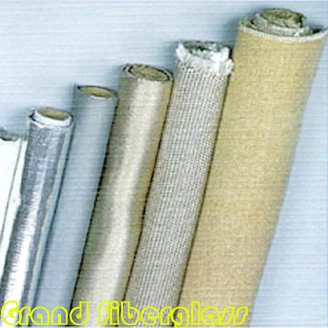
Product Name: Texturized Fiberglass Fabric
Place of Origin: China
Brand Name: Grand Fiberglass
Quality/Safety Certifications: ISO9001
Texturized fiberglass fabrics are applicable for insulation of pipes and tubes, as insulation cladding in heating and cooling processes, for the production of fire blankets, and insulation of equipment on ships. We have many specifications, as detailed below:
Company Name: Grand Fiberglass Co., Ltd.
Contact Person: Richard Lu
Address: 513 Zhongxing Road, Ningbo, Zhejiang Province. China
Zip: 315040
Tel: +86-574-87808408,87802848
Fax: +86-574-87803039
E-Mail: grandco@vip.163.com lurichard@163.com
Website: www.fibreglassmesh.com/
Other Products Fiberglass, Fiberglass Mesh , Fire Blanket , fiberglass tissue ,Fiberglass Tape , fiberglass mesh tape, scrim tape , self adhesive fiberglass tape , drywall joint tape , fiberglass disc , Grinding Wheel , grinding disc , abrasive wheel , texturized fiberglass Fabric , fiberglass fabric, fiberglass cloth , fiberglass insect screen , insect screen ,mosquito net , FRP grating , FRP Profile ,FRP bathtub, drywall mesh tape, paper tape, drywall paper tape, flexible metal corner tape, drywall corner tape,abrasive mesh screen, sanding screen, abrasive mesh, wowen roving, chopped strand mat,needled felt

